
SYNGENTA: VAT INTEGRATION

Document Information
Template Author
Template Reviewer
Owner / Team

Document Review & Sign-off
Reviewers
Role | Name | Comments Received | Approved | Date
PDA | Jitendra Shirsath
SCA | Varun Agarwal

Revision History
Version No. | Date | Author | Revision Description
1.0 | 12/07/2023 | S.Prabhu | Initial Draft

Other Related Documents
<Please insert links to related Documents (issues, data entities, Check list OR quality check document etc.).>
Related Document | Comment
SDD (Mandatory)
BRS Document (Mandatory) | NA
Unit test document
Message Mapping (Mandatory)

Contents
Sign-off Checklist 5
1 Header Information 7
1.1 Executive Summary 7
1.2 Purpose 7
2 Business process Overview 8
2.1 Current Scenario 8
2.2 To-Be Scenario 8
2.3 Messaging Choreography 8
3 Fun ctional Overview 9
3.1 Interface Requirement and Background 9
3.2 Functional Description 9
3.3 Interface Process Flow Diagram 10
3.4 Functional Dependencies and Constraints 10
3.5 Functional Assumptions 10
3.5.1 Frequency 10
3.5.2 Transaction Volume 10
3.5.3 Initiating Process/ Transaction/ Program 10
3.5.4 Processing Type 10
3.5.5 Performance 10
3.5.6 Proposed Transfer Method/ Program 10
3.5.7 Archival and Re-Run Requirements 10
3.5.8 Error and Notification Requirements 11
3.5.9 Re-Use Details 11
3.5.10 Data Migration Requirements 11
4 Technical Overview 12
4.1 High Level Design 12
4.1.1 Usage of Standard SAP Enterprise Services 12
4.1.2 BRM/Value Mapping Requirement and Usage 12
4.2 Technical Dependencies/Constraints 12
4.3 Technical Assumptions 12
4.4 Design Considerations 12
4.5 Other Requirements 12
4.5.1 Security, Integrity, and Controls 12
4.5.1.1 Security and Authorization Configuration 12
4.5.1.2 Authentication Level 12
5 Development Overview 13
5.1 Interface Type 13
5.2 Technical Flow Diagram 13
5.3 Technical Flow Description 13
5.4 Source Data layout 13
5.5 Target Data layout 13
5.6 Mapping representation 13
5.7 BPM Workflow Diagram 13
5.8 Network Integration 13
5.9 Interface Scheduling Requirement 13
5.10 Key Validation and Error Handling 13
5.10.1 Alert 14
5.10.2 Message Alerting 14
6 OUT of the Box Solutions 15
6.1 Description 15
6.2 Configuration 15
7 Interface Details 16
7.1 RMFT Technical details 16
7.1.1 Source Details 16
7.1.1.1 Source Host 16
7.1.1.2 Source Directory 16
7.1.2 Target Details 17
7.1.2.1 Target Host 17
7.1.2.2 Target Directory 17
7.1.3 Pull Job 17
7.2 Integration Suite Technical details 19
7.2.1 System Landscape Configuration 19
7.2.1.1 Systems Catalog 19
7.2.1.2 Software Catalog 19
7.2.2 Integration Repository 20
7.2.2.1 Interface Objects 20
7.2.2.1.1 Sender Objects 20
7.2.2.1.2 BDO Objects 21
7.2.2.1.3 Receiver Objects 21
7.2.2.1.4 Mapping Objects 22
7.2.2.1.4.1 Message Mapping 22
7.2.2.1.4.2 Function Libraries 22
7.2.2.1.4.3 User Defined Functions 22
7.2.2.1.4.4 Operation Mapping 22
7.2.2.1.4.5 Imported Archive 23
7.2.3 Integration Directory 23
7.2.3.1 iFlow 23
7.2.3.2 Communication Component for <Source – Target Integration Name> 23
7.2.3.2.1 Communication Channel 23
7.2.3.3 Adapter Modules 23
7.2.3.4 Receiver Determination Rule 24
7.2.3.5 Integrated Configuration Object (ICO) 24
7.2.3.5.1 Sender 24
7.2.3.5.2 Receiver 24
7.2.4 NetWeaver BPM 24
7.2.4.1 BPM Overview 24
7.2.4.2 Diagramatic represention of the BPM 24
7.2.5 BRM 24
7.2.5.1 Flow Ruleset 25
7.3 Informatica Cloud Technical details 25
7.3.1 Task Flow 25
7.3.2 Connections 25
7.4 CPI-DS Technical details 26
7.4.1 Flow Details 26
7.4.1.1 Task Name 26
7.4.1.2 Data Flows 26
7.4.2 Datastores Configurations 26
7.4.3 Transformations 26
7.4.3.1 Filter & Time Horizon 26
7.4.3.2 Transformation Steps. 26
7.4.4 Scripts 26
7.4.4.1 Preload Scripts 26
7.4.4.2 Postload Scripts. 26
7.4.4.3 Global Variables. 26
7.4.5 Flow Schedules 26
8 Interface Cutover/Steady State Details 27
8.1 Queue Details 27
8.1.1 Large Message Queue details 27
8.1.2 Quality of Services (EO/ EOIO/ Best Effort) 27
8.1.3 Queue Prioritization Details 27
8.2 Data Retention 27
8.3 Outstanding Issues 27
9 Appendix 27
9.1 Glossary of Terms 27
9.2 Additional Supporting/Reference Documentation 27
10 Acronyms 28

Sign-off Checklist
<Use the following checklist to guide your completion of the Technical Specification Document>
Standards and Consistency
Has the correct template been used and all sections been completed as required?
Are the correct details (Business Owner for sign-off, status, etc.) displayed on the front page?
Have all the assumptions been documented properly so that there are no open issues in the document?
Has the document history been continuously updated?
Integration and Dependencies
Have all inputs and outputs been identified and confirmed?
Have all referenced documents been listed (other business process designs, sub process designs, spreadsheets, information papers, etc.)?
Design
Has the report development technique been identified?
Has an example of existing RICEF object been included?
If the report is of type modification (custom development), has it been approved?
Have all areas of impact been identified?
Performance
Have the performance implications, metrics and targets been documented?
Has the performance and volume usage of the report development been considered?
Exceptions and Error Handling
Have the exceptions and likely errors been defined and listed?
Does the document describe what steps (if any) need to be taken after an exception has been raised?
Have all the applicable business scenarios been considered, along with the corresponding test conditions?
Usability – From the user perspective
Has the report attempted to maximize the efficiency of the user (i.e. simple to use, intuitive, quick to use)?
Are any manual steps clearly defined and carefully designed?
Flexibility – From a business perspective
Have all steps been clearly identified and documented so new functionality can be added in the future?
Additional information
Has security been considered (e.g. authority checking considered, target group of users who should be given access to the report, etc.)?
Are the test conditions sufficiently detailed to enable a full test of all required functionality?
Document Integrity and Consistency
Has the correct template been used and all sections been completed as required?
Is the naming convention followed?
Is Syngenta OASIS (design and security) guidelines followed?
Are all the links and other object attachments required captured and valid?
Is the Technical Walkthrough complete?
Are the review comments captured and closed?

Header Information

Executive Summary
VAT Integration project aims at integrating the GSAP system with the VAT System. The scope of this project is to send Party, FGReceive, Material Master, Purchase, Sales and Transfer, FG Receive, Consumption, VDS, Toll Receive, Toll Challan Issue, Credit Note and Debit Note data to VAT system.

Purpose
This document details the technical design of the interface between GSAP system and VAT system to send Consumption data using Integration Suite as the middleware integration tool.

Business process Overview

Current Scenario
There is no interface to transfer Consumption data from GSAP system to VAT system.

To-Be Scenario
Create an Integration flow in Integration Suite to send Consumption data from GSAP system to VAT system.

Messaging Choreography

Functional Overview

Interface Requirement and Background
GSAP_Consumption_VAT
Short description | This interface deals with sending Consumption data from GSAP to VAT system.
Business Area |  |  | Date
Business Module | NA |  | Process Component | NA
 |  |  | Business Object
 |  |  | Activity
Requested by |  |  | Email
New scenario | Yes No
Business Criticality | High/mandatory Medium/recommended Low/optional
Business Impact  Results if no solution is created: |  | Legal requirements not fulfilled  Lack of essential business information  Lack of functions compared to legacy system  Others:
Is there an alternative in the standard system / Contingency? |  | Yes No
Description of alternative:
Reasons why alternative is not acceptable: |  | Performance problems Complexity  Others:

Functional Description
The outbound delivery process is vital to the logistics operation. The outbound logistics functionality covers the picking and packing of Consumption as well as the outbound delivery and goods issue.

Interface Process Flow Diagram
Consumption data from GSAP System to VAT System
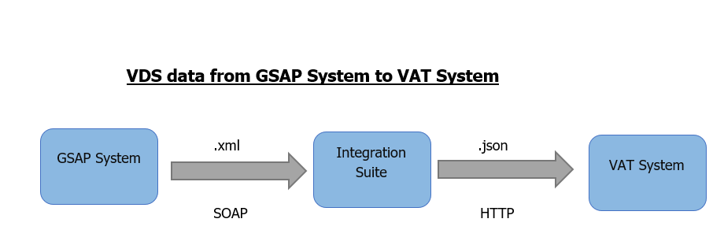

Functional Dependencies and Constraints
User training and acceptance test to ensure respective Logistics users and Warehouse Managers are familiar with the new changes

Functional Assumptions
This project will neither replace nor decommission any existing system.

Frequency
Real time.

Transaction Volume
TBU

Initiating Process/ Transaction/ Program
Consumption data will be in GSAP system and triggered and will be sent to VAT system through HTTPS adapter in Integration Suite.

Processing Type
Data is processed as .json files.

Performance
NA

Proposed Transfer Method/ Program
Source will be SOAP connection and Target will be HTTPS connection.

Archival and Re-Run Requirements
NA

Error and Notification Requirements
NA

Re-Use Details

Data Migration Requirements
NA

Technical Overview

High Level Design
- The interface will get triggered at Integration Suite’s end once the Consumption data are being placed in GSAP system.
- Integration Suite will be receiving the Consumption data through SOAP adapter from GSAP system.
- Integration Suite will send the Consumption to VAT system via HTTPS connection.

Usage of Standard SAP Enterprise Services
NA

BRM/Value Mapping Requirement and Usage
NA

Out of the Box
NA

Technical Dependencies/Constraints
NA

Technical Assumptions

Design Considerations

Security, Integrity, and Controls

Security and Authorization Configuration
While connecting to API towards VAT system, we have used HTTPS connection and authentication is done using API Key.

Authentication Level
Header: XAPIKey

Development Overview

Interface Type
This is an outbound interface from GSAP system to VAT system.

Technical Flow Diagram
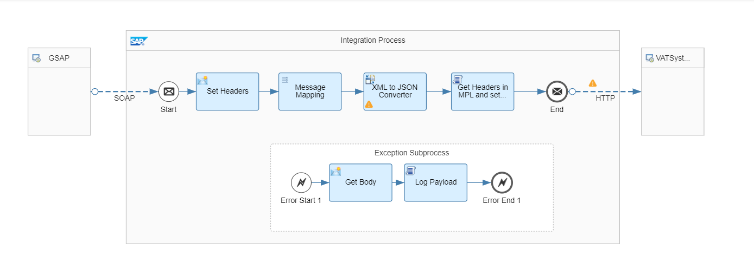

Technical Flow Description
- Sender System: GSAP system will send Payload.
- SOAP Adapter: Sender System will send Payload through SOAP Adapter.
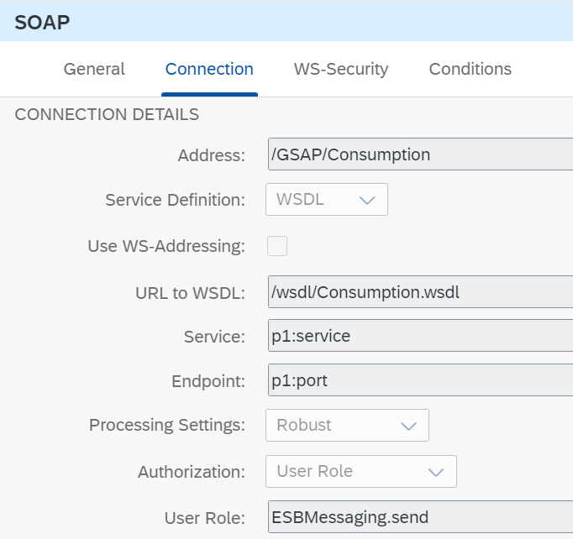

- Content Modifier: Define required header with specific values.
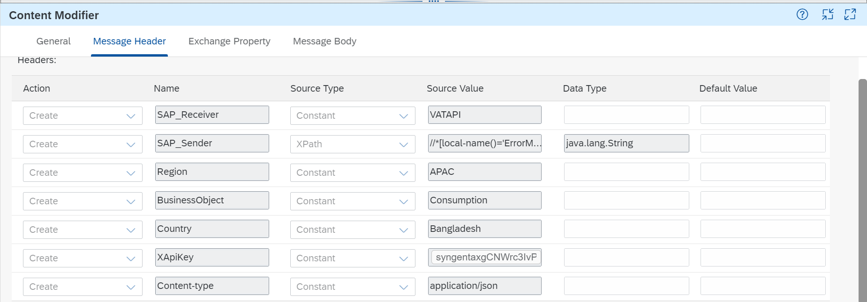
- Message Mapping: Map and transform Structure of Payload.
- XML to JSON Converter: Convert XML Payload into JSON Payload.
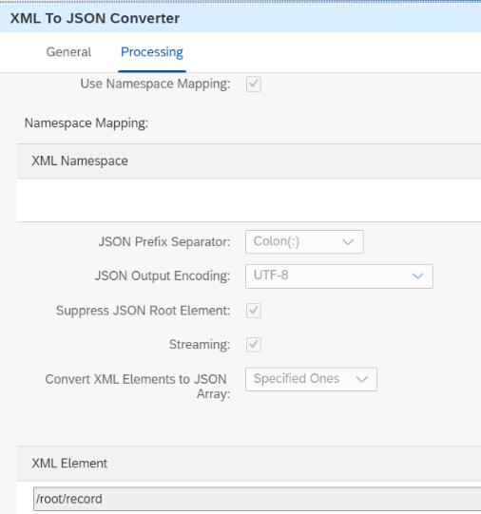

- Groovy Script: Load Header into MPL(Message Processing Log) and set required structure of payload according to target system.
- HTTPS Adapter: Post Payload to API
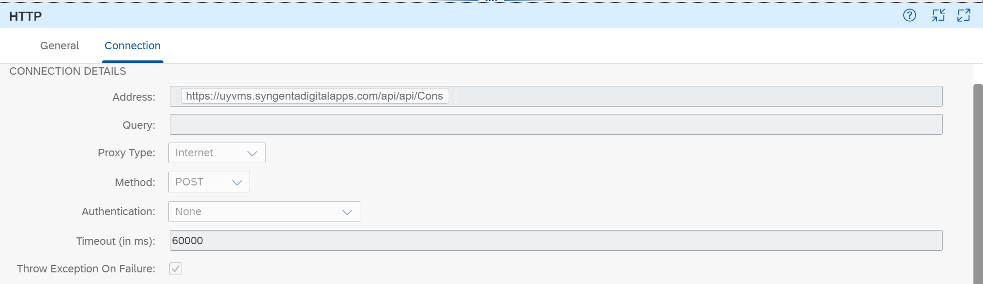

- Receiver System: VAT system will receive Payload in required JSON structure.
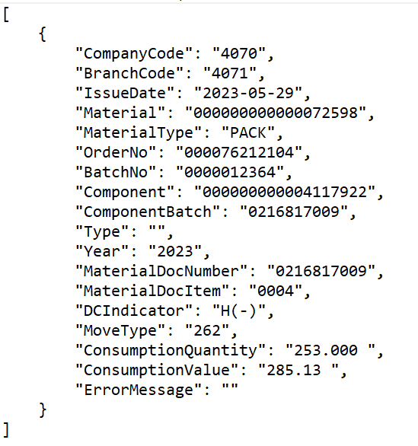

Source Data layout

Target Data layout

Mapping representation

BPM Workflow Diagram
NA

Network Integration

Interface Scheduling Requirement
Real Time.

Key Validation and Error Handling

Error | How error message should be reported | Error message | Corrective Actions
All Error or failures in IFlow. | Exception handling will get triggered with a payload in MPL. |  | Based on the error message, support team will take the required action.

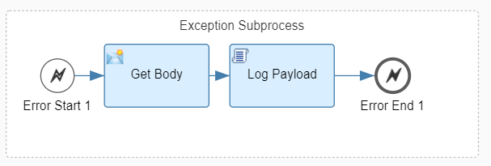
- Content Modifier: Get Payload as body.



- Groovy Script: Log the Payload in MPL.

Alert
NA

Message Alerting
NA

OUT of the Box Solutions

Description
NA

Configuration
NA

Interface Details

Technical details

Source Details
IFlow Name | Adapter Type | Address
GSAP_Consumption_VAT | SOAP | /GSAP/Consumption

Target Details
IFlow Name | Adapter Type | Address
GSAP_Consumption_VAT | HTTPS | UAT:  https://test.uyvms.syngentadigitalapps.com/api/api/Consumption/Add  PROD:  https://uyvms.syngentadigitalapps.com/api/api/Consumption/Add

SAP Integration Suite Technical details

System Landscape Configuration

Systems Catalog
Associated Business Systems | <Sender>:
Type of System | WAS ABAP Third Party WAS Java Stand-Alone
Associated Business Systems | <Receiver>:
Type of System | WAS ABAP Third Party WAS Java Stand-Alone

IFLOW Screenshot

IFLOW Technical Details:

7.2.1.3.1 Package Details:
Package Id: Product Info
Supported Platform: Integration Suite

7.2.1.3.2 IFLOW Name:
GSAP_Consumption_VAT
7.2.1.3.3 Groovy Script:
Log Payload:
Get Headers in MPL:
7.2.1.3.4 XSLT Mapping (If any)
NA

7.2.1.3.5 Converter
XML to JSON:
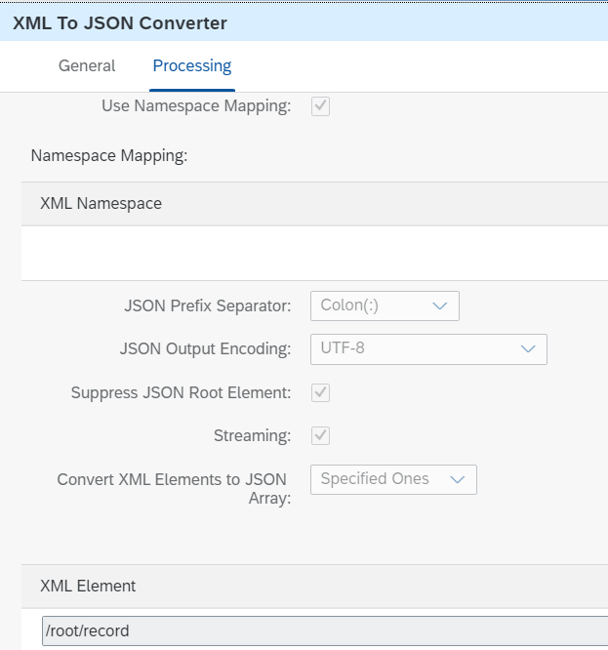

Interface Objects

Acronyms
Acronym | Expansion

